Possible Echosounder Research:

1. <https://bluerobotics.com/store/sensors-sonars-cameras/sonar/ping-sonar-r2-rp/>
2. <https://www.kongsberg.com/maritime/products/marine-robotics/underwater-vehicle-instruments/single-beam-scanning-sonars/domed-scanning-sonar/#technicalInformation>
3. <https://seatronics-group.com/rov-sensors/teledyne-blueview-m900-deep-series/>
4. <https://www.benthowave.com/products/BII-7560echosounder.html>
5. <https://www.echologger.com/applications/obstacle-avoidance>
6. <https://benthowave.com/products/BII-8050echosounder.html>
7. <https://cdn.discordapp.com/attachments/784624813611941941/811788391930658836/Sea_Scan_ECHO_Spec_Sheet.pdf>

|  |  |  |  |  |  |  |  |
| --- | --- | --- | --- | --- | --- | --- | --- |
| Company | Product | Price | Dimensions  (diameter) | Range | Beam Pattern | Frequency | Connection |
| Blue Robotics | Ping | $279 | 1.89” | 30 m | 30° single beam | 115 kHz | RS-485 or UART |
| Marine Sonic | Sea Scan Echo | $1860 | 1.85” | 100 m | 6° single beam (two way) | 540 kHz | RS-232 |
| Echologger | ECT400S | $2700 | 2.2” | 100 m | 5° conical | 450 kHz | RS-232, 485, 422 |
| Kongsberg | Domed Sonar  1171 | ? | 4.22” exterior mount | 75 - 100 m | 22°-41° | 675 kHz - 1000 kHz | RS-232 or RS-485 |
| Teledyne | Blueview M900 | ? | 4” | 100 m | 130° 2D multibeam | 900 kHz | Ethernet (UDP and TCP/IP) |
| Benthowave | BII-7560 | ? | ? | ? | 4.6° conical (two way) | 1000 kHz | ? |

Marine Sonic:

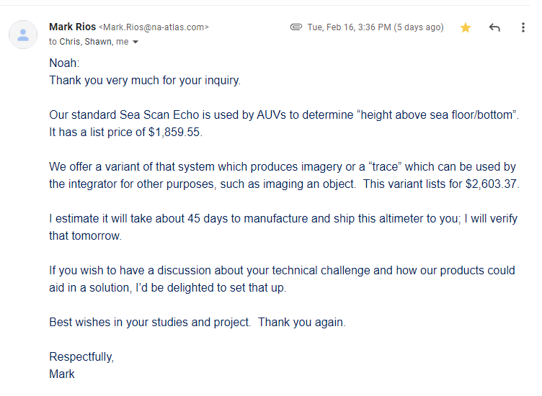

Benthowave:

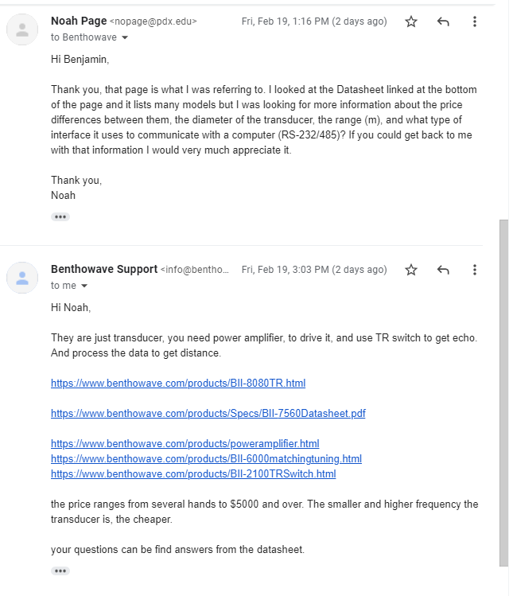

Kongsberg:

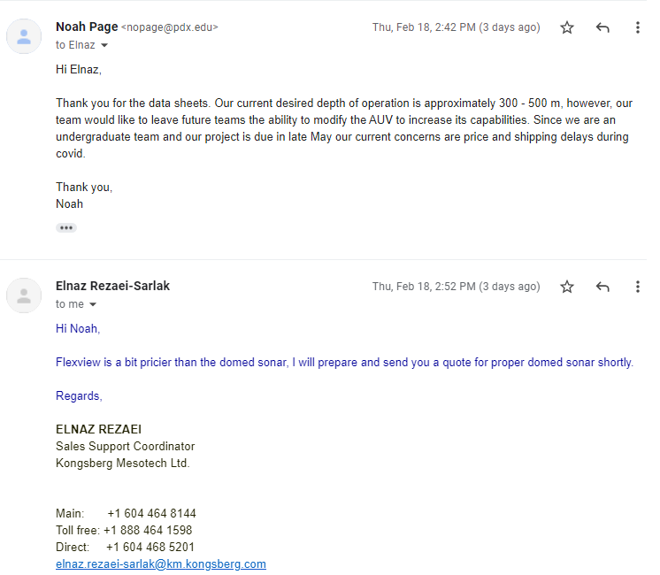

Echologger:

